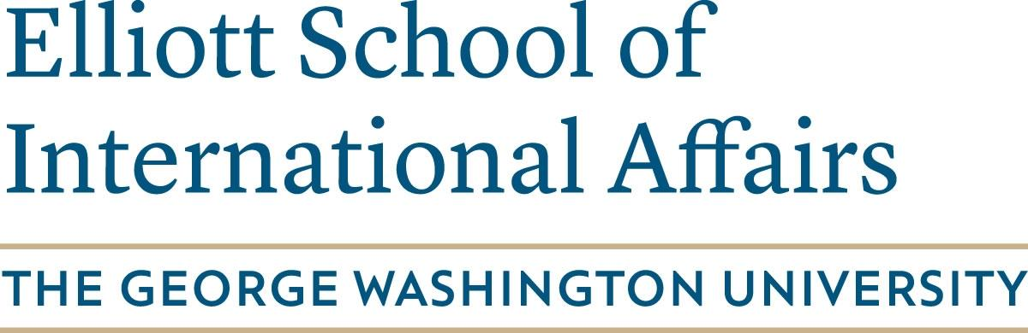

Elliott School Undergraduate Research Award

The George Washington University is committed to increasing the level and visibility of undergraduates in faculty-mentored research. The university’s strategic plan identifies the promotion of faculty-mentored independent research as a key way in which undergraduate students can engage themselves more fully in the research side of this university. The Elliott School Undergraduate Research Award encourages students to engage with faculty, deepen their learning, and practice various methodologies.

To be eligible for an Undergraduate Research Award, the student must identify a full-time GW faculty advisor willing to guide the student’s own research. The faculty advisor should have substantive expertise related to the student’s proposed topic. The faculty advisor will be expected to guide the student’s research through regular meetings.

To indicate this commitment, please fill out the form below and deliver or email to:

Jonathan Walker
1957 E St NW, Suite 401
Washington, DC 20052
jmwalker@gwu.edu

Student Name: | ______________________________________
GWid: | ______________________________________
Working Title of Paper: |  | ______________________________________
I, the applicant, understand the requirements of this agreement and am committed to this research:
Student Signature: | ______________________________________
Date: | ______________________________________

Faculty Advisor Name: | ______________________________________
Faculty Advisor Department: | ______________________________________
Faculty Advisor Email: |  | ______________________________________
I, the faculty advisor, have discussed and approved the student’s topic. I understand the requirements of this agreement and am committed to guiding the student through this research:

Faculty Advisor Signature: | ______________________________________
Date: | ______________________________________

Please contact Jonathan Walker at jmwalker@gwu.edu with questions.

